**CREATIVES [AUG 08, 2024]**

**DESIGN PATTERNS BEFORE GETTING STARTED**

|  |  |  |
| --- | --- | --- |
| **Theme** | **Palette** | **Sample** |
| Blue | #041e5f #072b8a #0a4ca5 #1b75c5 |  |
| Purple | #5B16E3  #9D20FF  #ff1d83  #ff66c4 |  |

**Note:** samples provided are samples only, feel free to express your creativity

**Resources:** <https://drive.google.com/drive/u/1/folders/1Pmp1FGi_4XCpGZY7pm4Rg2izrZJgRXr5>

**-> Jerome Agarin**

**About:** Cloud Skills Challenge

**Type:** Event Pubmat

**Theme:** Any (Purple)

**Details:**

Create **two** event pubmat (same template, just two separate events) for cloud skills challenge:

* **Title:** Get started with GitHub and GitHub Copilot
* **Title:** Get Started with Python
* **Subtitle (for both titles)**
  + Join Cloud Skills Challenge and take this free course through Microsoft's Student Learn Platform

This is a great starting point already, just modify a bit to fit perfectly the brand of the org (make the text standout a bit through applying neon effect or shadow):

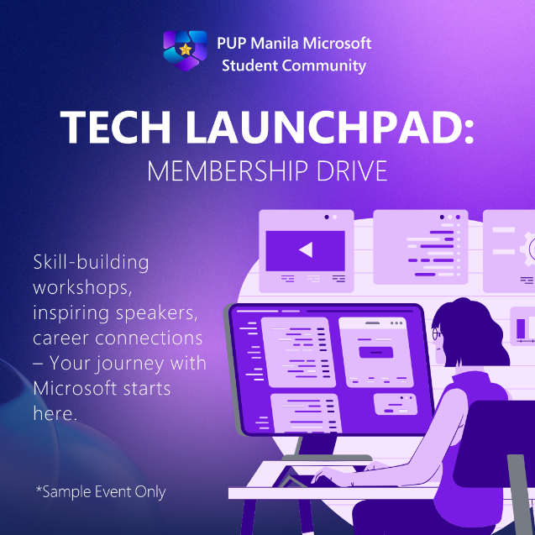

**Deadline:** August 20, 2024

**-> Submissions**

<https://drive.google.com/drive/folders/14Du8XmVkaNMKLRn59VdkK_9ee_CqQdlv?usp=drive_link>